**An Efficient and Fine-grained Big Data Access Control Scheme with Privacy-preserving Policy**

How to control the access of the huge amount of big data becomes a very challenging issue, especially when big data are stored in the cloud. Ciphertext-Policy Attribute based Encryption (CP-ABE) is a promising encryption technique that enables end-users to encrypt their data under the access policies defined over some attributes of data consumers and only allows data consumers whose attributes satisfy the access policies to decrypt the data. In CP-ABE, the access policy is attached to the ciphertext in plaintext form, which may also leak some private information about end-users. Existing methods only partially hide the attribute values in the access policies, while the attribute names are still unprotected. In this paper, we propose an efficient and fine-grained big data access control scheme with privacy-preserving policy. Specifically, we hide the whole attribute (rather than only its values) in the access policies. To assist data decryption, we also design a novel Attribute Bloom Filter to evaluate whether an attribute is in the access policy and locate the exact position in the access policy if it is in the access policy. Security analysis and performance evaluation show that our scheme can preserve the privacy from any LSSS access policy without employing much overhead.

**Index Terms—Big Data; Access Control; Privacy-preservingPolicy; Attribute Bloom Filter; LSSS Access Structure**

**EXISTING SYSTEM:**

In order to enable end-users to control the access of their own data stored on untrusted remote servers (e.g., cloud servers), encryption-based access control is an effective method, where data are encrypted by end-users and only authorized users are given decryption keys. This can also prevent the data security during the transmission over wireless networks which are vulnerable to many threats .However, traditional public key encryption methods are not suitable for data encryption because it may produce multiple copies of ciphertext for the same data when there are many data consumers in the system. In order to cope with this issue, some attribute-based access control schemes are proposed by leveraging attribute-based encryption which only produces one copy of ciphertext for each data anddoes not need to know how many intended data consumers during the data encryption. Moreover, once the cloud data are encrypted, some searchable encryption algorithms are proposed to support search on encrypted cloud data.

**PROPOSED SYSTEM:**

1. We propose an efficient and fine-gained big data access control scheme with privacy-preserving policy, where the whole attributes are hidden in the access policy rather than only the values of the attributes.

2) We also design a novel Attribute Bloom Filter to evaluate whether an attribute is in the access policy and locate the exact position in the access policy if it is in the access policy.

3) We further give the security proof and performance evaluation of our proposed scheme, which demonstrate that our scheme can preserve the privacy from any LSSS access policy without employing much overhead.

**MODULES:**

The system consists of five entities, namely

1. **Cloud Servers**
2. **Attribute Authority**
3. **End-users,**
4. **Data Consumers**

**Cloud Servers** Cloud Servers are employed to store, share and process big data in the system. The cloud servers are managed by cloud service providers, who are not in the same trust domain as end-users. Thus, cloud servers cannot be trusted by end-users to enforce the access policy and make access decisions. We also assume that the cloud server cannot collude with any End-users or Data Consumers.

**Attribute Authority** The attribute authority manages all the attributes in the system and assigns attributes chosen from the attribute space to end-users. It is also a key generation center, where the public parameters are generated. It also grants different access privileges to end-users by issuing secret

keys according to their attributes. The attribute authority is assumed to be fully trusted in the system.

**End-user End-users** are the data owners/producers who outsource their data into the cloud. They also would like to control the access of their data by encrypting the data with CP-ABE. End-users are assumed to be honest in the system.

**Data Consumers** Data consumers request the data from cloud servers. Only when their attributes can satisfy the access policies of the data, data consumers can decrypt the data. However, data consumers may try to collude together to access some data that are not accessible individually.

**SYSTEM REQUIREMENTS:**

**HARDWARE REQUIREMENTS:**

* System : Pentium Dual Core.
* Hard Disk : 120 GB.
* Monitor : 15’’ LED
* Input Devices : Keyboard, Mouse
* Ram : 1GB.

**SOFTWARE REQUIREMENTS:**

* Operating system : Windows 7.
* Coding Language : JAVA/J2EE
* Tool : Netbeans 7.2.1
* Database : MYSQL

**1. INTRODUCTION**

In the era of big data, a huge amount of data can be generated quickly from various sources (e.g., smart phones, sensors, machines, social networks, etc.). Towards these big data, conventional computer systems are not competent to store and process these data. Due to the flexible and elastic computing resources, cloud computing is a natural fit for storing and processing big data. With cloud computing, end-users store their data into the cloud, and rely on the cloud server to share their data to other users (data consumers). In order to only share end-users’ data to authorized users, it is necessary to design access control mechanisms according to the requirements of end-users.  
When outsourcing data into the cloud, end-users lose the physical control of their data. Moreover, cloud service providers are not fully-trusted by end-users, which makes the access control more challenging. For example, if the traditional access control mechanisms (e.g., Access Control Lists) are applied, the cloud server becomes the judge to evaluate the access policy and make access decision. Thus, end-users may worry that the cloud server may make wrong access decision intentionally or unintentionally, and disclose their data to some unauthorized users. In order to enable end-users to control the access of their own data, some attribute-based access control schemes are proposed by leveraging attribute-based encryption. In attribute-based access control, end-users first define access policies for their data and encrypt the data under these access policies. Only the users whose attributes can satisfy the access policy are eligible to decrypt the data. Although the existing attribute-based access control schemes can deal with the attribute revocation problem, they all suffer from one problem: the access policy may leak privacy. This is because the access policy is associated with the encrypted data in plaintext form. From the plaintext of access policy, the adversaries may obtain some privacy information about the end-user. For example, Alice encrypts her data to enable the “Psychology Doctor” to access. So, the access policy may contain the attributes “Psychology” and “Doctor”. If anyone sees this data, although he/she may not be able to decrypt the data, he/she still can guess that Alice may suffer from some psychological problems, which leaks the privacy of Alice.

To prevent the privacy leakage from the access policy, a straightforward method is to hide the attributes in the access policy. However, when the attributes are hidden, not only the unauthorized users but also the authorized users cannot know which attributes are involved in the access policy, which makes the decryption a challenging problem. Due to this reason, existing methods do not hide or anonymize the attributes. Instead, they only hide the values of each attribute by using wildcards, Hidden Vector Encryption, and Inner Product Encryption. Hiding the values of attributes can somehow protect user privacy, but the attribute name may also leak private information. Moreover, most of these partially hidden policy schemes only support specific policy structures (e.g., AND-gates on multi-valued attributes). In this paper, we aim to hide the whole attribute instead of only partially hiding the attribute values. Moreover, we do not restrict our method to some specific access structures.

The basic idea is to express the access policy in LSSS access structure (M;r) where M is a policy matrix and r matches each row Mi of the matrix M to an attribute [6], and hide the attributes by simply removing the attribute matching function r. Without the attribute matching function r, it is necessary to design an attribute localization algorithm to evaluate whether an attribute is in the access policy and if so find the correct position in the access policy. To this end, we further build a novel Attribute Bloom Filter to locate the attributes to the anonymous access policy, which can save a lot of storage overhead and computation cost especially for large attribute universe.

Our contributions are summarized as follows.

1) We propose an efficient and fine-gained big data access control scheme with privacy-preserving policy, where the whole attributes are hidden in the access policy rather than only the values of the attributes.

2) We also design a novel Attribute Bloom Filter to evaluate whether an attribute is in the access policy and locate the exact position in the access policy if it is in the access policy.

3) We further give the security proof and performance evaluation of our proposed scheme, which demonstrate that our scheme can preserve the privacy from any LSSS access policy without employing much overhead.

**SYSTEM ARCHITECTURE**

Architecture Flow:

Below architecture diagram represents mainly flow of request from the users to database through servers. In this scenario overall system is designed in three tiers separately using three layers called presentation layer, business layer, data link layer. This project was developed using 3-tier architecture.

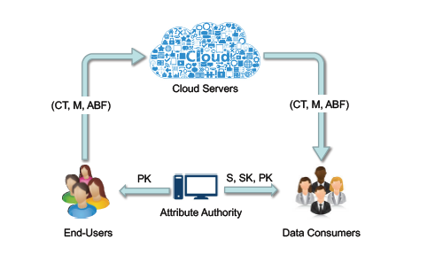

3-Tier Architecture:

The three-tier software architecture (a three layer architecture) emerged in the 1990s to overcome the limitations of the two-tier architecture. The third tier (middle tier server) is between the user interface (client) and the data management (server) components. This middle tier provides process management where business logic and rules are executed and can accommodate hundreds of users (as compared to only 100 users with the two tier architecture) by providing functions such as queuing, application execution, and database staging.

The three tier architecture is used when an effective distributed client/server design is needed that provides (when compared to the two tier) increased performance, flexibility, maintainability, reusability, and scalability, while hiding the complexity of distributed processing from the user. These characteristics have made three layer architectures a popular choice for Internet applications and net-centric information systems

.

**Advantages of Three-Tier:**

* Separates functionality from presentation.
* Clear separation – better understanding.
* Changes limited to well define components.
* Can be running on WWW.
* Effective network performance.

**SYSTEM DESIGN**

System Design Introduction:

The System Design Document describes the system requirements, operating environment, system and subsystem architecture, files and database design, input formats, output layouts, human-machine interfaces, detailed design, processing logic, and external interfaces.

**UML DIAGRAMS**

Global Use Case Diagrams:

Identification of actors:

Actor: Actor represents the role a user plays with respect to the system. An actor interacts with, but has no control over the use cases.

Graphical representation:

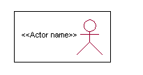

<<Actor name>>

An actor is someone or something that:

Interacts with or uses the system.

* Provides input to and receives information from the system.
* Is external to the system and has no control over the use cases.

Actors are discovered by examining:

* Who directly uses the system?
* Who is responsible for maintaining the system?
* External hardware used by the system.
* Other systems that need to interact with the system.

Questions to identify actors:

* + Who is using the system? Or, who is affected by the system? Or, which groups need help from the system to perform a task?
  + Who affects the system? Or, which user groups are needed by the system to perform its functions? These functions can be both main functions and secondary functions such as administration.
  + Which external hardware or systems (if any) use the system to perform tasks?
  + What problems does this application solve (that is, for whom)?
  + And, finally, how do users use the system (use case)? What are they doing with the system?

The actors identified in this system are:

1. System Administrator
2. Customer
3. Customer Care

Identification of usecases:

Usecase: A use case can be described as a specific way of using the system from a user’s (actor’s) perspective.

Graphical representation:

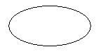

A more detailed description might characterize a use case as:

* Pattern of behavior the system exhibits
* A sequence of related transactions performed by an actor and the system
* Delivering something of value to the actor

Use cases provide a means to:

* capture system requirements
* communicate with the end users and domain experts
* test the system

Use cases are best discovered by examining the actors and defining what the actor will be able to do with the system.

Guide lines for identifying use cases:

* For each actor, find the tasks and functions that the actor should be able to perform or that the system needs the actor to perform. The use case should represent a course of events that leads to clear goal
* Name the use cases.
* Describe the use cases briefly by applying terms with which the user is familiar.

This makes the description less ambiguous

Questions to identify use cases:

* What are the tasks of each actor?
* Will any actor create, store, change, remove or read information in the system?
* What use case will store, change, remove or read this information?
* Will any actor need to inform the system about sudden external changes?
* Does any actor need to inform about certain occurrences in the system?
* What usecases will support and maintains the system?

1.2 **Flow of Events**

A flow of events is a sequence of transactions (or events) performed by the system. They typically contain very detailed information, written in terms of what the system should do, not how the system accomplishes the task. Flow of events are created as separate files or documents in your favorite text editor and then attached or linked to a use case using the Files tab of a model element.

A flow of events should include:

* When and how the use case starts and ends
* Use case/actor interactions
* Data needed by the use case
* Normal sequence of events for the use case
* Alternate or exceptional flows

**Construction of Usecase diagrams:**

A use case diagram in the Unified Modeling Language (UML) is a type of behavioral diagram defined by and created from a Use-case analysis. Its purpose is to present a graphical overview of the functionality provided by a system in terms of actors, their goals (represented as use cases), and any dependencies between those use cases. The main purpose of a use case diagram is to show what system functions are performed for which actor. Roles of the actors in the system can be depicted.

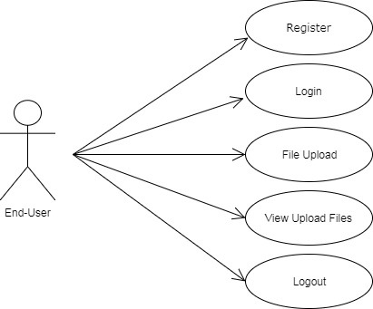

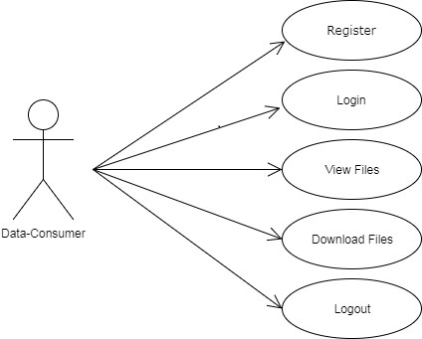

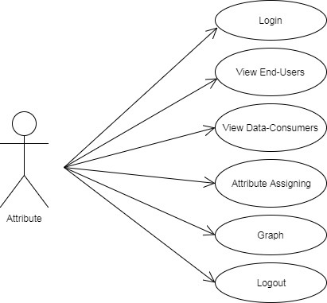

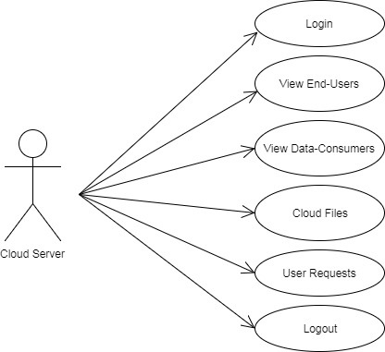

**SEQUENCE DIAGRAMS:**

A sequence diagram in Unified Modeling Language (UML) is a kind of interaction diagram that shows how processes operate with one another and in what order. It is a construct of a Message Sequence Chart. Sequence diagrams are sometimes called event diagrams, event scenarios, and timing diagrams.

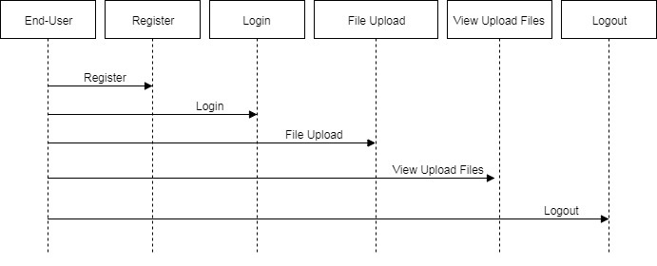

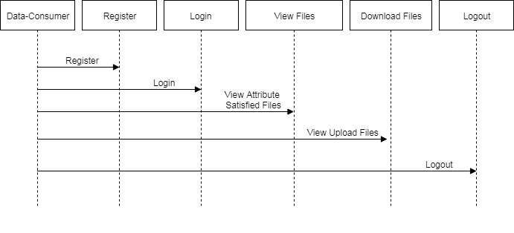

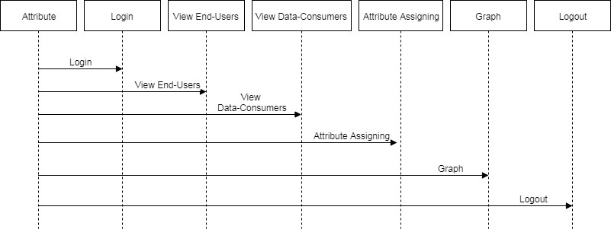

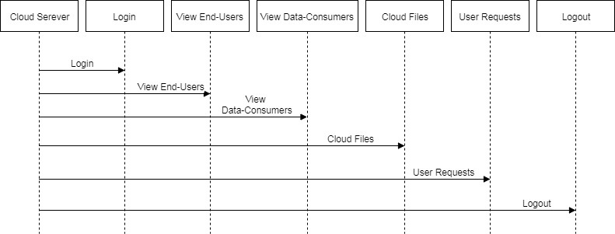

**CLASS DIAGRAM:**

In software engineering, a class diagram in the Unified Modeling Language (UML) is a type of static structure diagram that describes the structure of a system by showing the system's classes, their attributes, operations (or methods), and the relationships among the classes. It explains which class contains information.

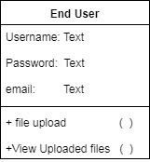

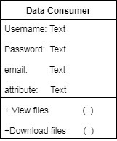

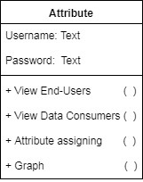

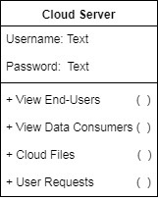

**ACTIVITY DIAGRAM:**

Activity diagrams are graphical representations of workflows of stepwise activities and actions with support for choice, iteration and concurrency. In the Unified Modeling Language, activity diagrams can be used to describe the business and operational step-by-step workflows of components in a system. An activity diagram shows the overall flow of control.

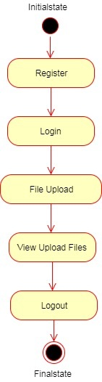

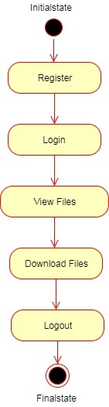

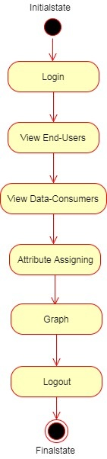

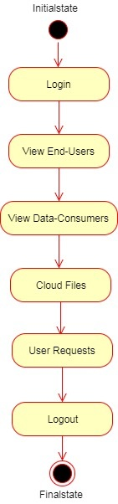

**LITERATURE SURVEY**

**Toward Efficient And Privacy-Preserving Computing In Big Data Era**

Big data, because it can mine new knowledge for economic growth and technical innovation, has recently received considerable attention, and many research efforts have been directed to big data processing due to its high volume, velocity, and variety (referred to as "3V") challenges. However, in addition to the 3V challenges, the flourishing of big data also hinges on fully understanding and managing newly arising security and privacy challenges. If data are not authentic, new mined knowledge will be unconvincing; while if privacy is not well addressed, people may be reluctant to share their data. Because security has been investigated as a new dimension, "veracity," in big data, in this article, we aim to exploit new challenges of big data in terms of privacy, and devote our attention toward efficient and privacy-preserving computing in the big data era. Specifically, we first formalize the general architecture of big data analytics, identify the corresponding privacy requirements, and introduce an efficient and privacy-preserving cosine similarity computing protocol as an example in response to data mining's efficiency and privacy requirements in the big data era.

**Expressive, Efficient, And Revocable Data Access Control For Multi-Authority Cloud Storage**

Data access control is an effective way to ensure the data security in the cloud. Due to data outsourcing and untrusted cloud servers, the data access control becomes a challenging issue in cloud storage systems. Ciphertext-Policy Attribute-based Encryption (CP-ABE) is regarded as one of the most suitable technologies for data access control in cloud storage, because it gives data owners more direct control on access policies. However, it is difficult to directly apply existing CP-ABE schemes to data access control for cloud storage systems because of the attribute revocation problem. In this paper, we design an expressive, efficient and revocable data access control scheme for multi-authority cloud storage systems, where there are multiple authorities co-exist and each authority is able to issue attributes independently. Specifically, we propose a revocable multi-authority CP-ABE scheme, and apply it as the underlying techniques to design the data access control scheme. Our attribute revocation method can efficiently achieve both forward security and backward security. The analysis and simulation results show that our proposed data access control scheme is secure in the random oracle model and is more efficient than previous works.

**Enabling Fine-Grained Access Control With Efficient Attribute Revocation And Policy Updating In Smart Grid**

In smart grid, electricity consumption data may be handed over to a third party for various purposes. While government regulations and industry compliance prevent utility companies from improper or illegal sharing of their customers’ electricity consumption data, there are some scenarios where it can be very useful. For example, it allows the consumers’ data to be shared among various energy resources so the energy resources are able to analyze the data and adjust their operation to the actual power demand. However, it is crucial to protect sensitive electricity consumption data during the sharing process. In this paper, we propose a fine-grained access control scheme (FAC) with efficient attribute revocation and policy updating in smart grid. Specifically, by introducing the concept of Third-party Auditor (TPA), the proposed FAC achieves efficient attribute revocation. Also, we design an efficient policy updating algorithm by outsourcing the computational task to a cloud server. Moreover, we give security analysis and conduct experiments to demonstrate that the FAC is both secure and efficient compared with existing ABE-based approaches.

**Time-Domain Attribute-Based Access Control For Cloud-Based Video Content Sharing: A Cryptographic Approach**

With the ever-increasing demands on multimedia applications, cloud computing, due to its economical but powerful resources, is becoming a natural platform to process, store, and share multimedia contents. However, the employment of cloud computing also brings new security and privacy issues as few public cloud servers can be fully trusted by users. In this paper, we focus on how to securely share video contents to a certain group of people during a particular time period in cloud-based multimedia systems, and propose a cryptographic approach, a provably secure time-domain attribute-based access control (TAAC) scheme, to secure the cloud-based video content sharing. Specifically, we first propose a provably secure time-domain attribute-based encryption scheme by embedding the time into both the ciphertexts and the keys, such that only users who hold sufficient attributes in a specific time slot can decrypt the video contents. We also propose an efficient attribute updating method to achieve the dynamic change of users' attributes, including granting new attributes, revoking previous attributes, and regranting previously revoked attributes. We further discuss on how to control those video contents that can be commonly accessed in multiple time slots and how to make special queries on video contents generated in previous time slots. The security analysis and performance evaluation show that TAAC is provably secure in generic group model and efficient in practice.

**Secure Threshold Multi Authority Attribute Based Encryption Without A Central Authority**

An attribute based encryption scheme (ABE) is a cryptographic primitive in which every user is identified by a set of attributes, and some function of these attributes is used to determine the ability to decrypt each ciphertext. Chase proposed the first multi authority ABE scheme in TCC 2007 as an answer to an open problem presented by Sahai and Waters in EUROCRYPT 2005. However, her scheme needs a fully trusted central authority which can decrypt every ciphertext in the system. This central authority would endanger the whole system if it’s corrupted.

This paper presents a threshold multi authority fuzzy identity based encryption(MA-FIBE) scheme without a central authority for the first time. An encrypter can encrypt a message such that a user could only decrypt if he has at least dk of the given attributes about the message for at least t + 1, t ≤ n/2 honest authorities of all the n attribute authorities in the proposed scheme. The security proof is based on the secrecy of the underlying joint random secret sharing protocol and joint zero secret sharing protocol and the standard decisional bilinear Diffie-Hellman assumption. The proposed MA-FIBE could be extended to the threshold multi authority attribute based encryption (MA-ABE) scheme and be further extended to a proactive MA-ABE scheme.

**Attribute-Based Encryption With Partially Hidden Encryptor-Specified Access Structures**

We propose attribute-based encryption schemes where encryptor-specified access structures (also called ciphertext policies) are hidden. By using our schemes, an encryptor can encrypt data with a hidden access structure. A decryptor obtains her secret key associated with her attributes from a trusted authority in advance and if the attributes associated with the decryptor’s secret key do not satisfy the access structure associated with the encrypted data, the decryptor cannot decrypt the data or guess even what access structure was specified by the encryptor. We prove security of our construction based on the Decisional Bilinear Diffie-Hellman assumption and the Decision Linear assumption. In our security notion, even the legitimate decryptor cannot obtain the information about the access structure associated with the encrypted data more than the fact that she can decrypt the data.

**Privacy-Aware Attribute-Based Encryption With User Accountability**

As a new public key primitive, attribute-based encryption (ABE) is envisioned to be a promising tool for implementing fine-grained access control. To further address the concern of user access privacy, privacy-aware ABE schemes are being developed to achieve hidden access policy recently. For the purpose of secure access control, there is, however, still one critical functionality missing in the existing ABE schemes, which is user accountability. Currently, no ABE scheme can completely prevent the problem of illegal key sharing among users. In this paper, we tackle this problem by firstly proposing the notion of accountable, anonymous, and ciphertext-policy ABE (CP-A3BE, in short) and then giving out a concrete construction. We start by improving the state-of-the-art of anonymous CP-ABE to obtain shorter public parameters and ciphertext length. In the proposed CP-A3BE construction, user accountability can be achieved in black-box model by embedding additional user-specific information into the attribute private key issued to that user, while still maintaining hidden access policy. The proposed constructions are provably secure.

**SCREEN SHOTS**

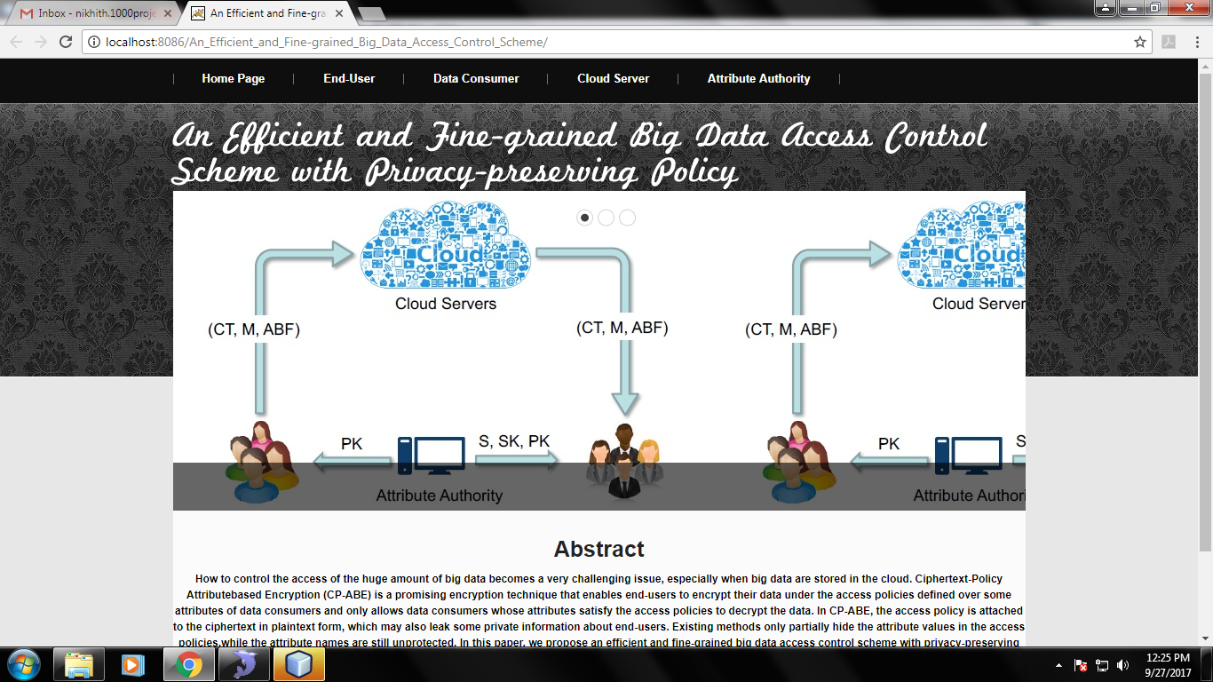

Fig: Home Page

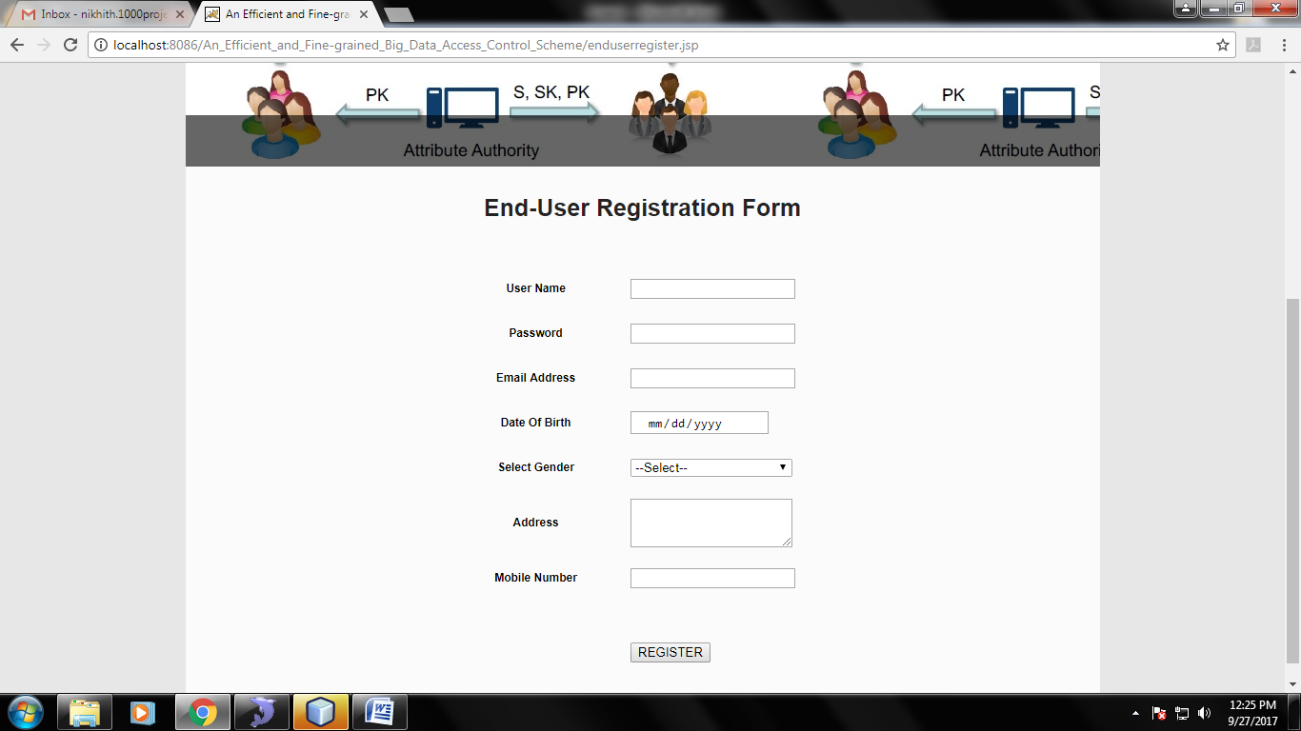

Fig: End-User registration

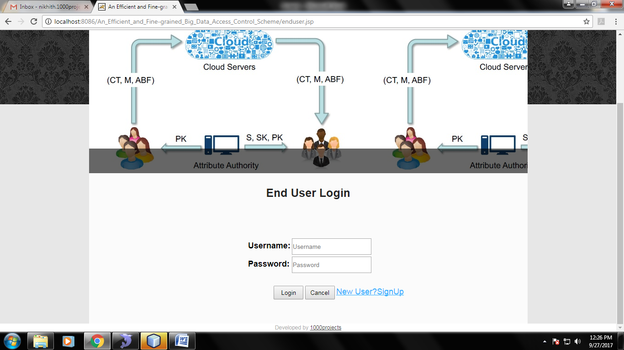

Fig: end-user Login

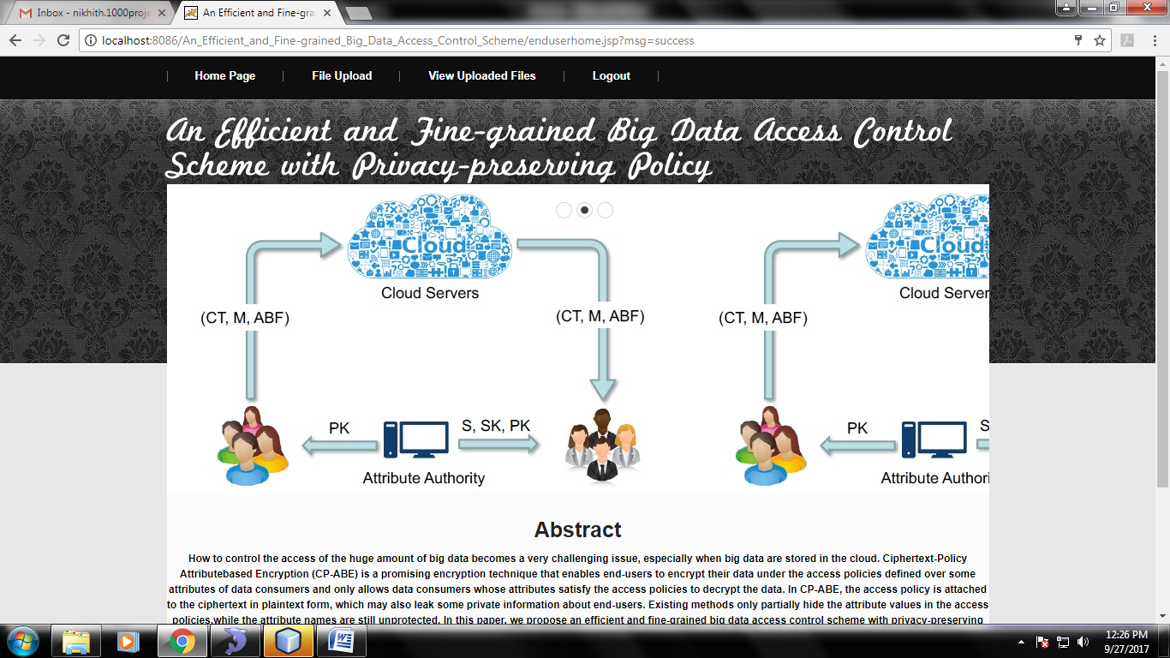

Fig: End User Home

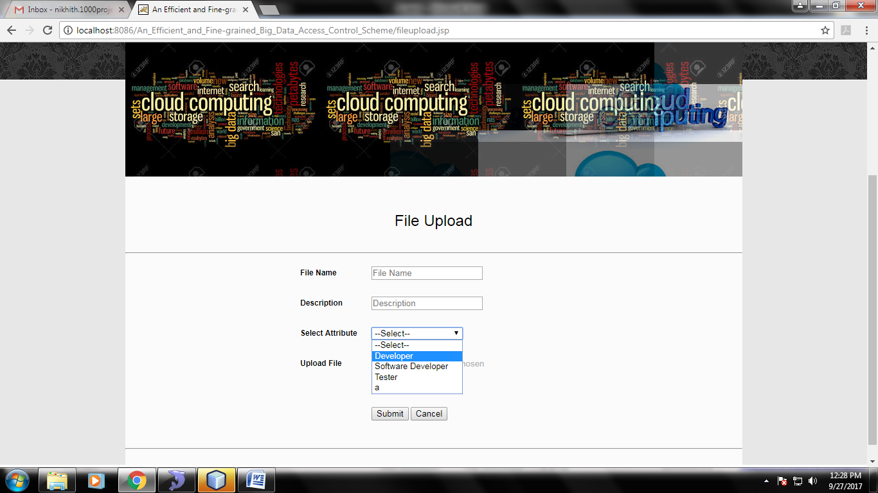

Fig: File Upload

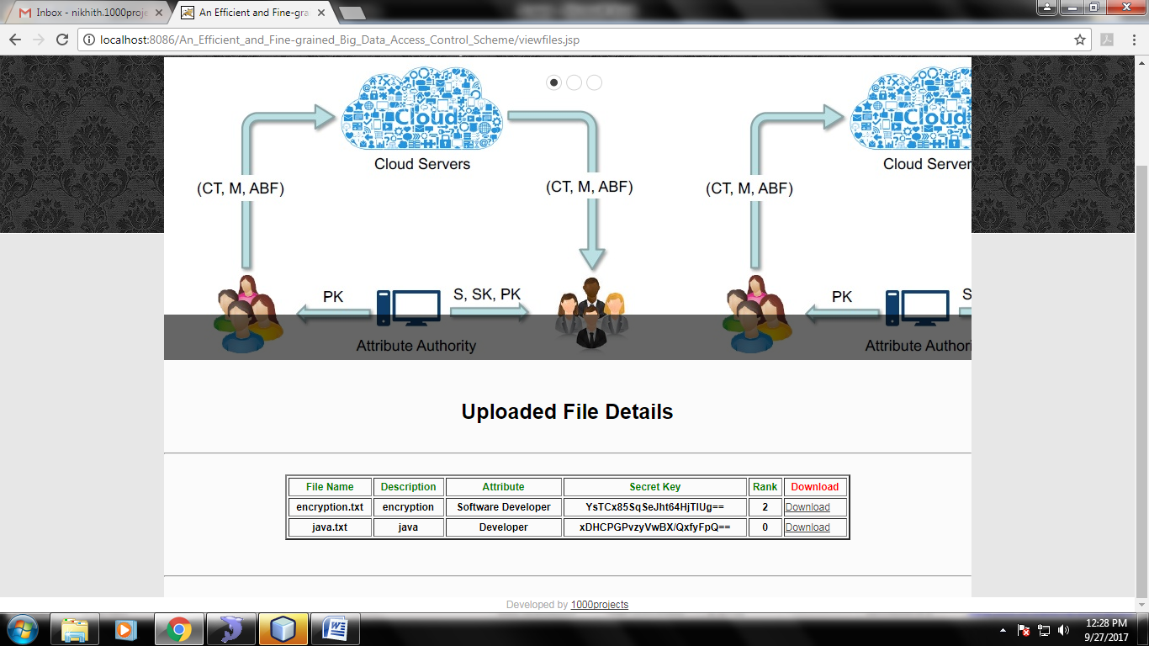

Fig: View Uploaded File Details

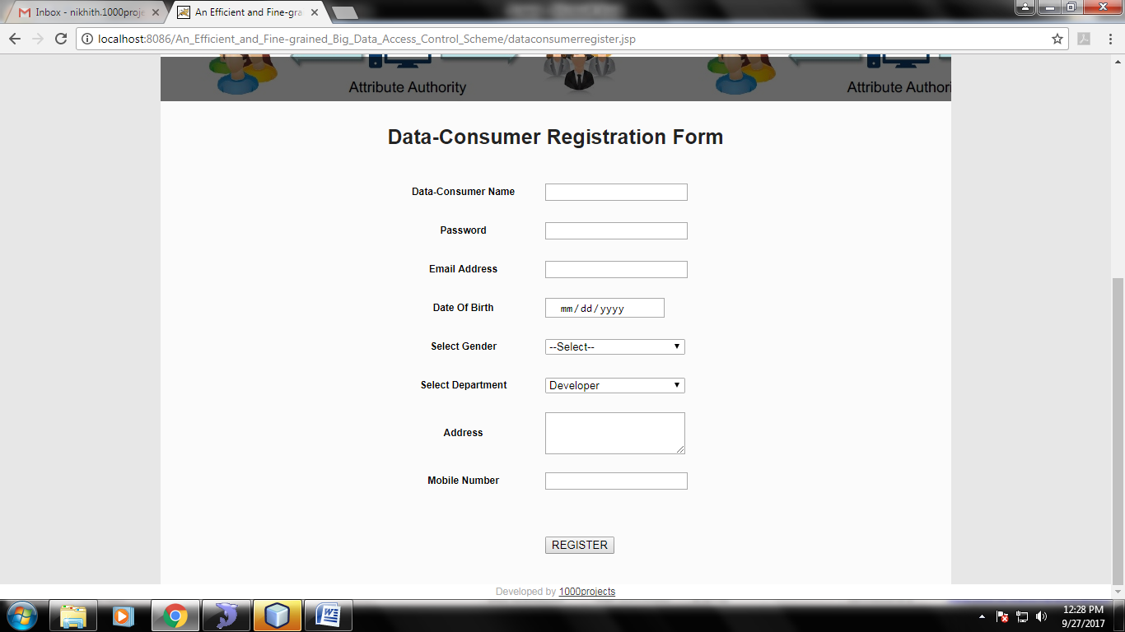Fig: Data-Consumer Registration

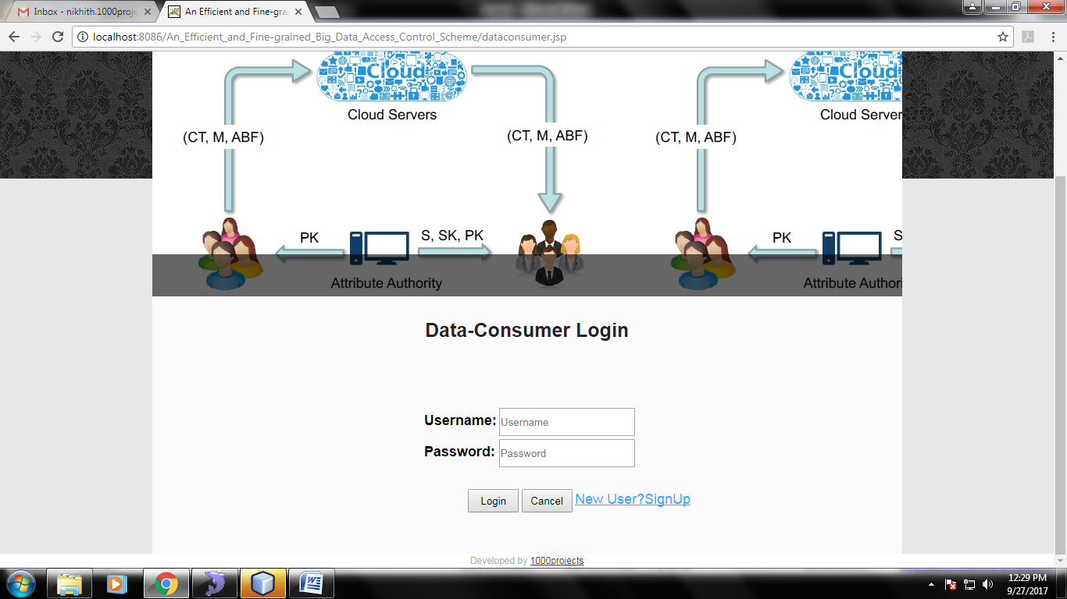

Fig: Data- Consumer Login

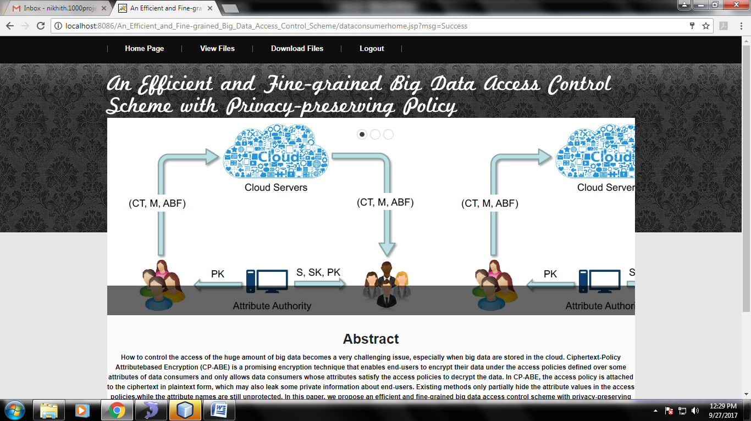

Fig: Data-Consumer Home

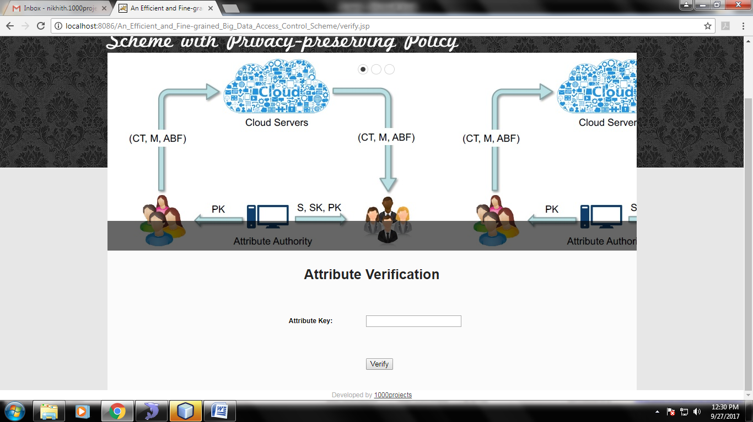

Fig: Verify Attributes

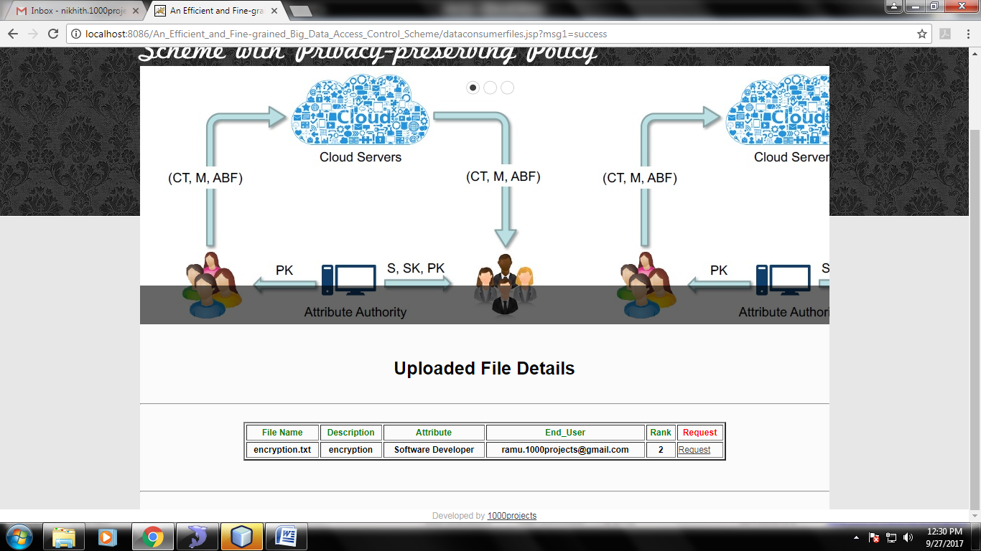

Fig: View Attribute Matched Files



Fig: Verify Attributes

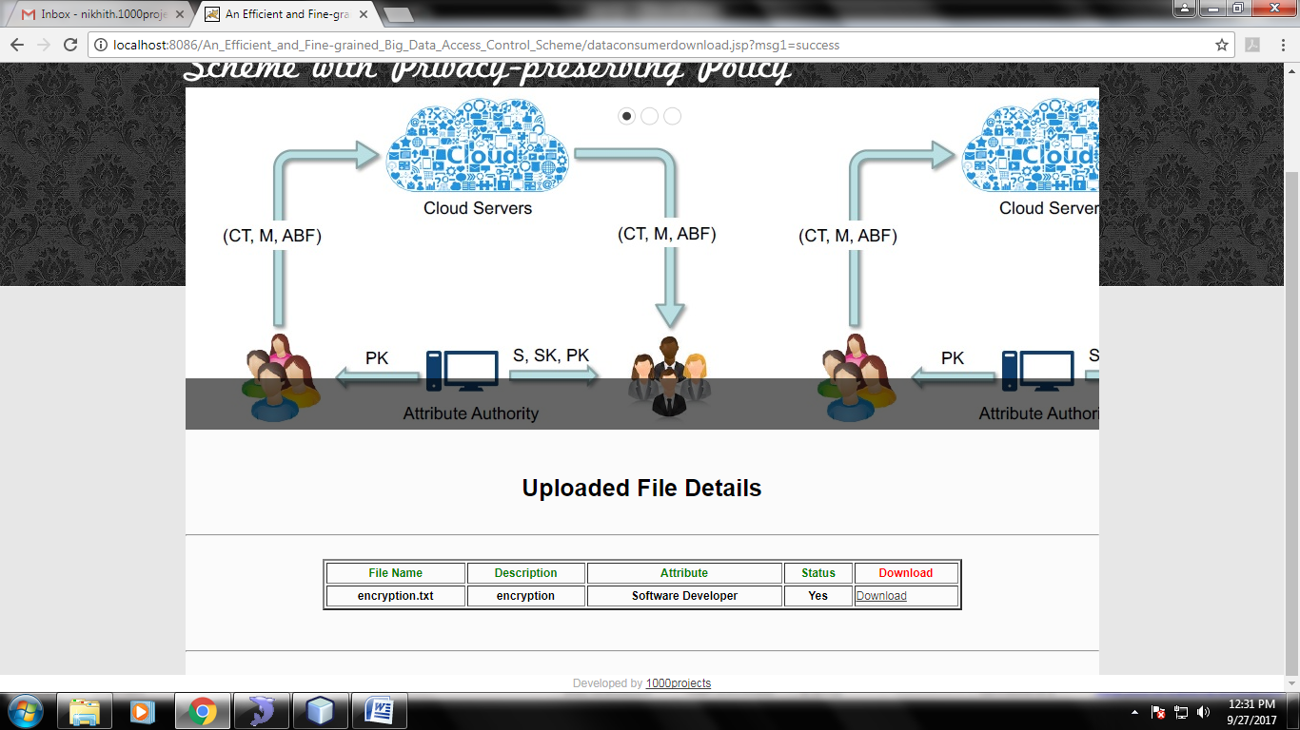

Fig: Download Files

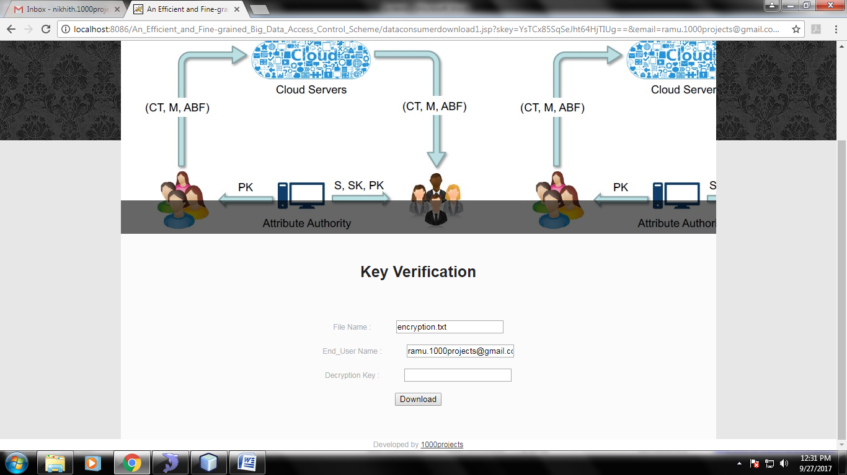

Fig: Key Verification and Download files

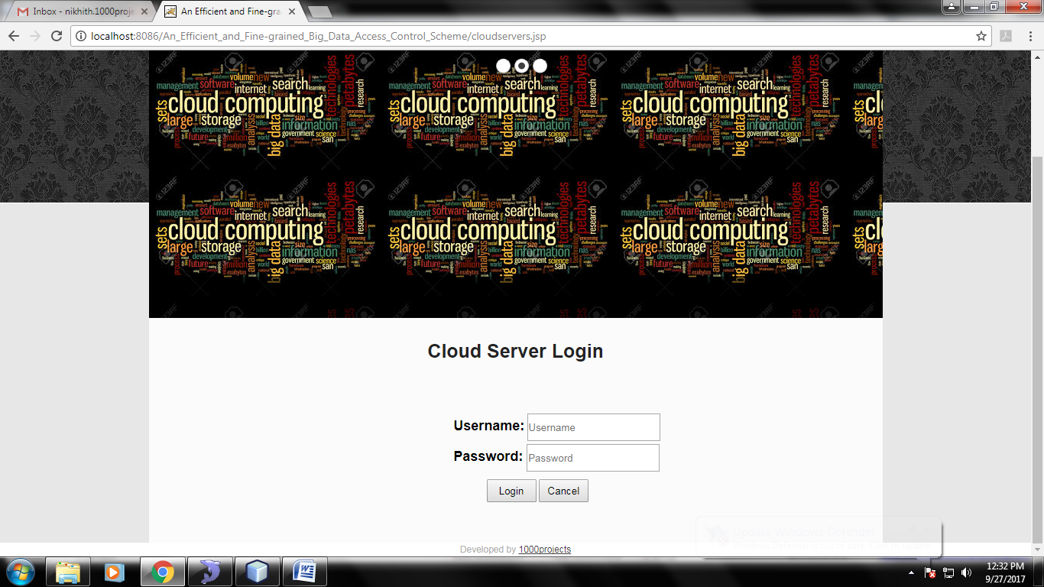

Fig: Cloud Server Login Page

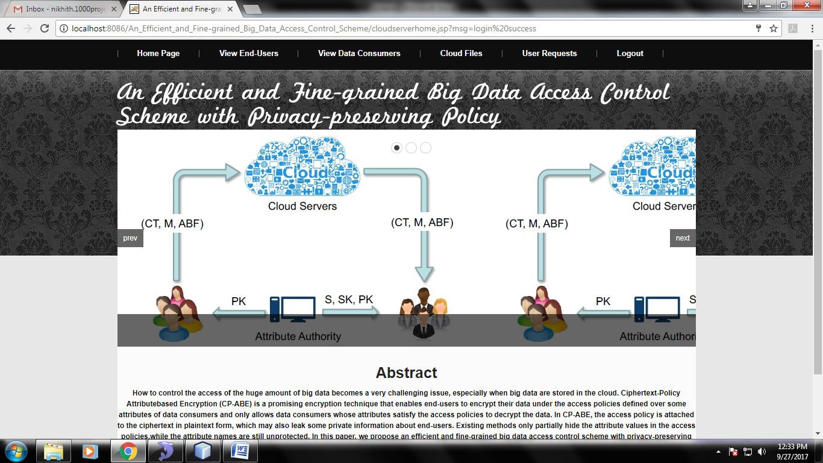

Fig: Cloud Server home

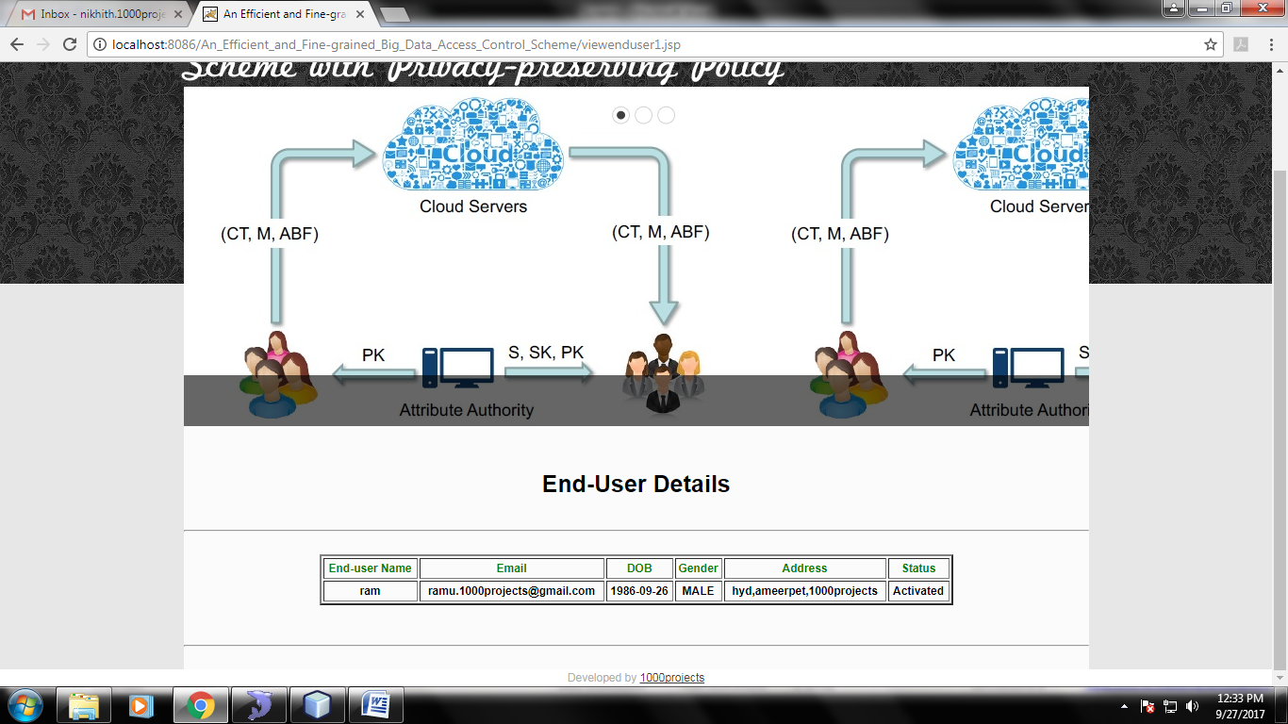

Fig: View End-User Details

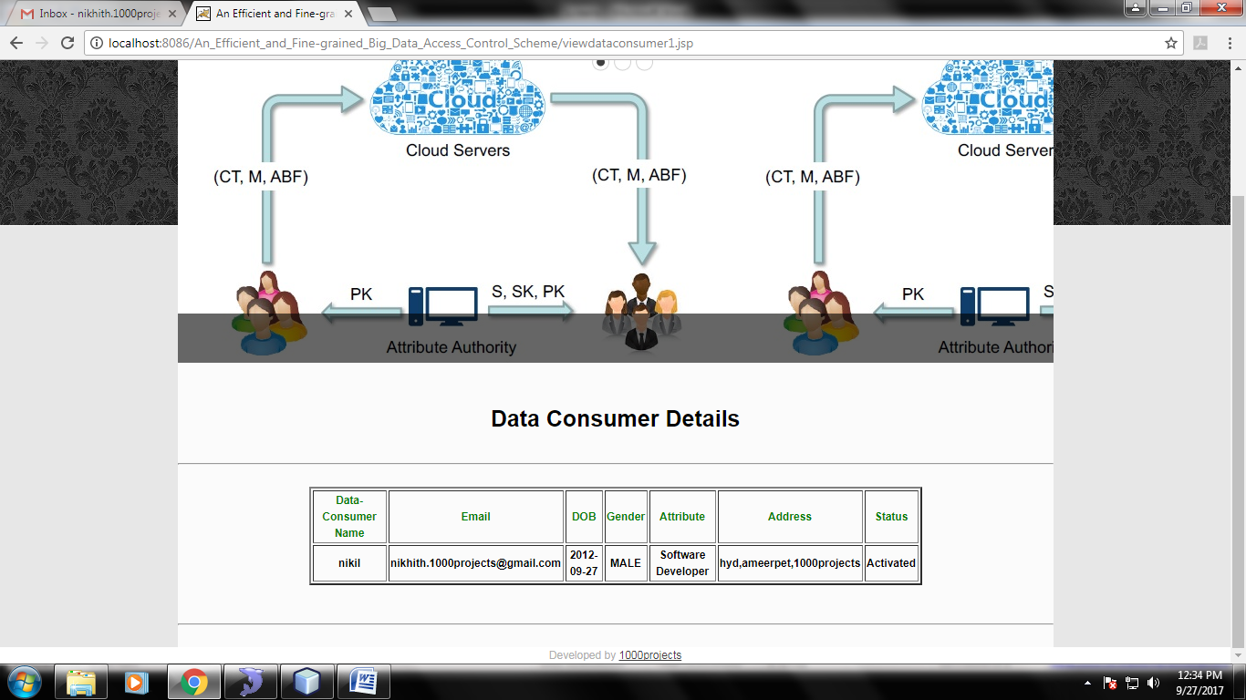

Fig: View Data-Consumer Details

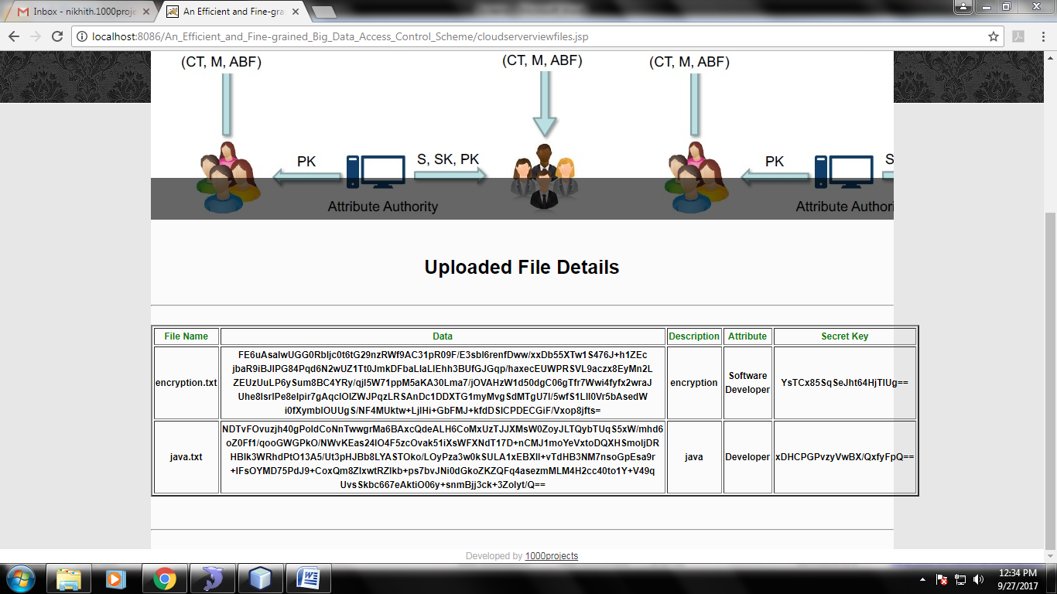

Fig: View cloud Files

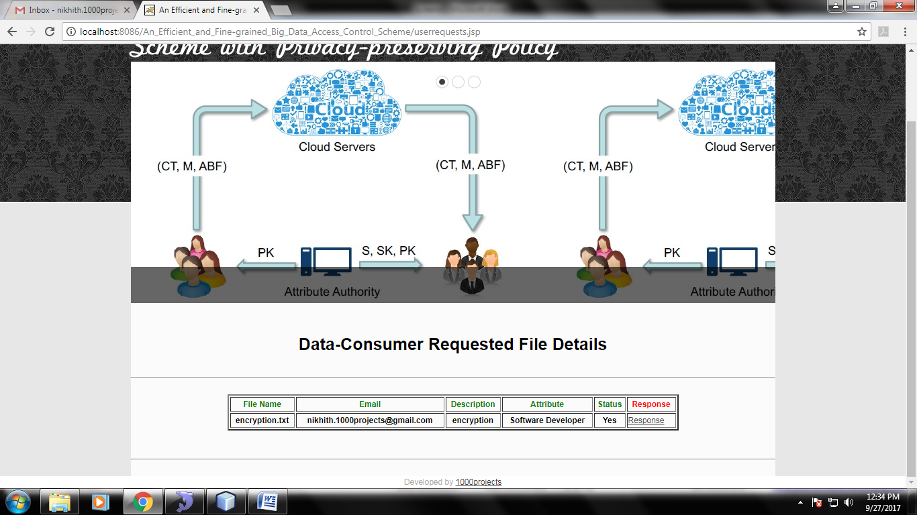

Fig: View User Requests

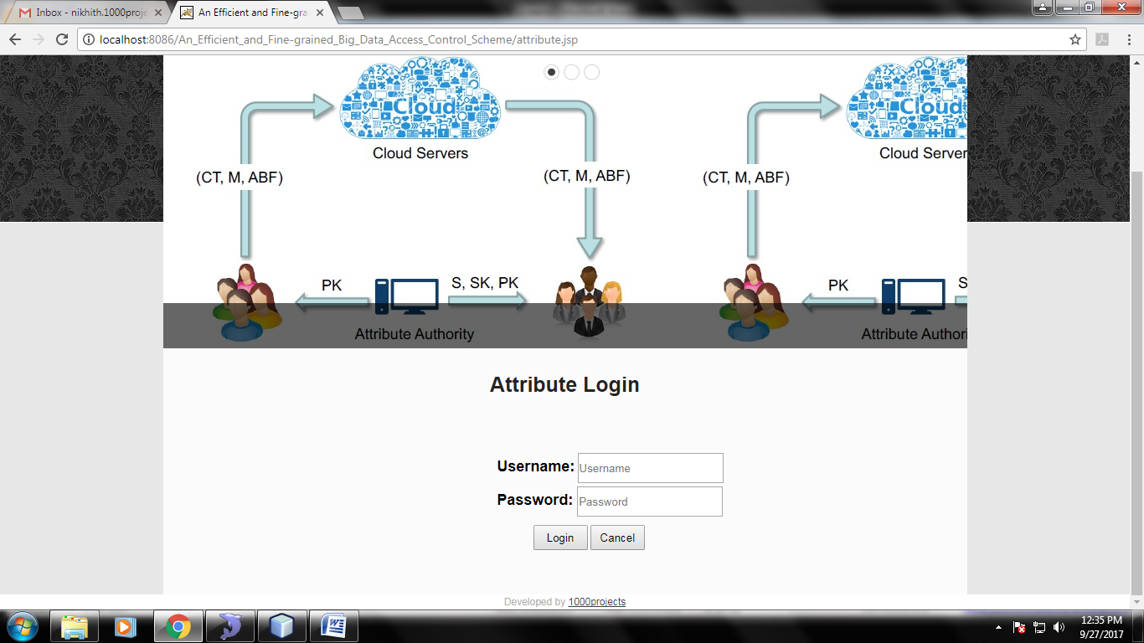

Fig: Attribute Login

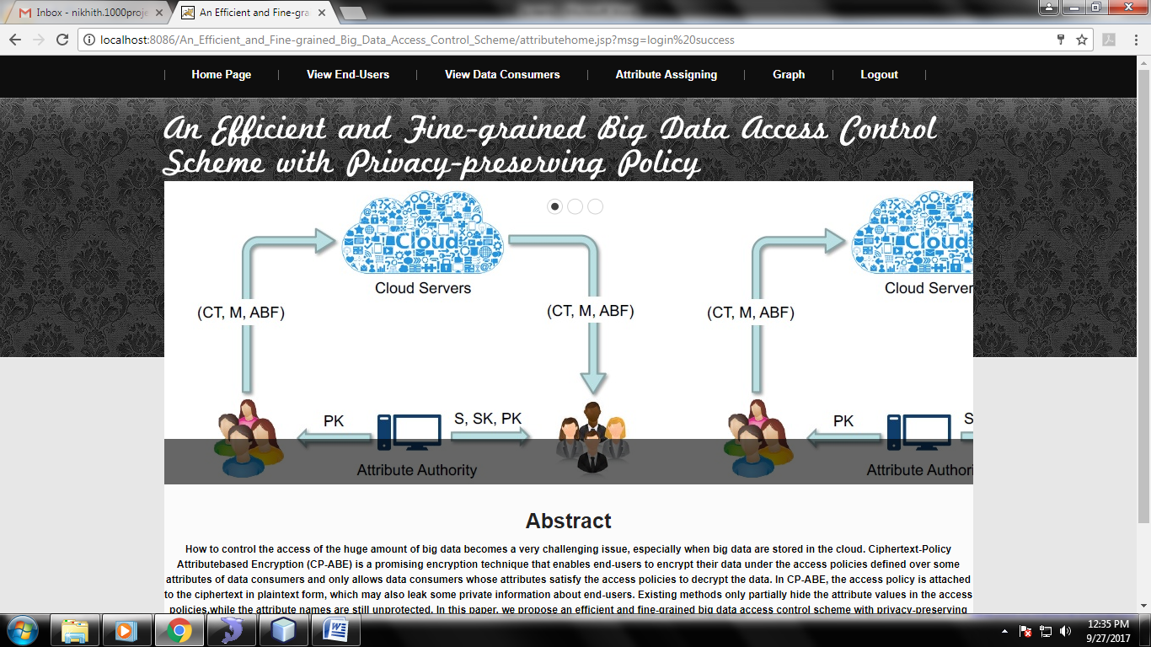

Fig: Attribute Home

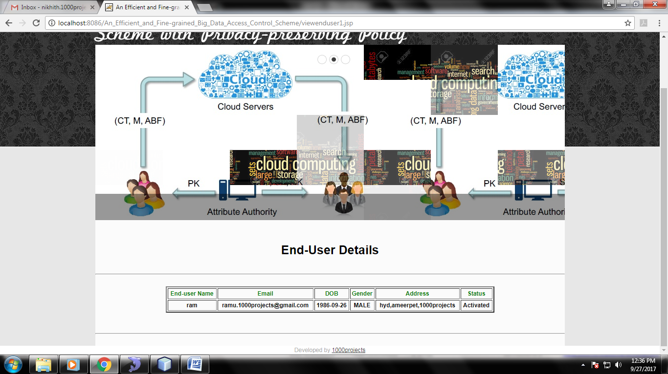

Fig: View End-User and Activate and Deactivate

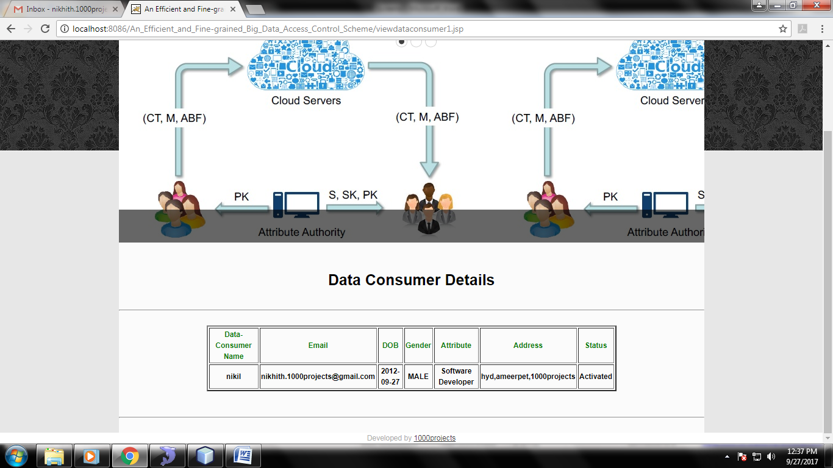

Fig: View Data-Consumers and Activate and Deactivate

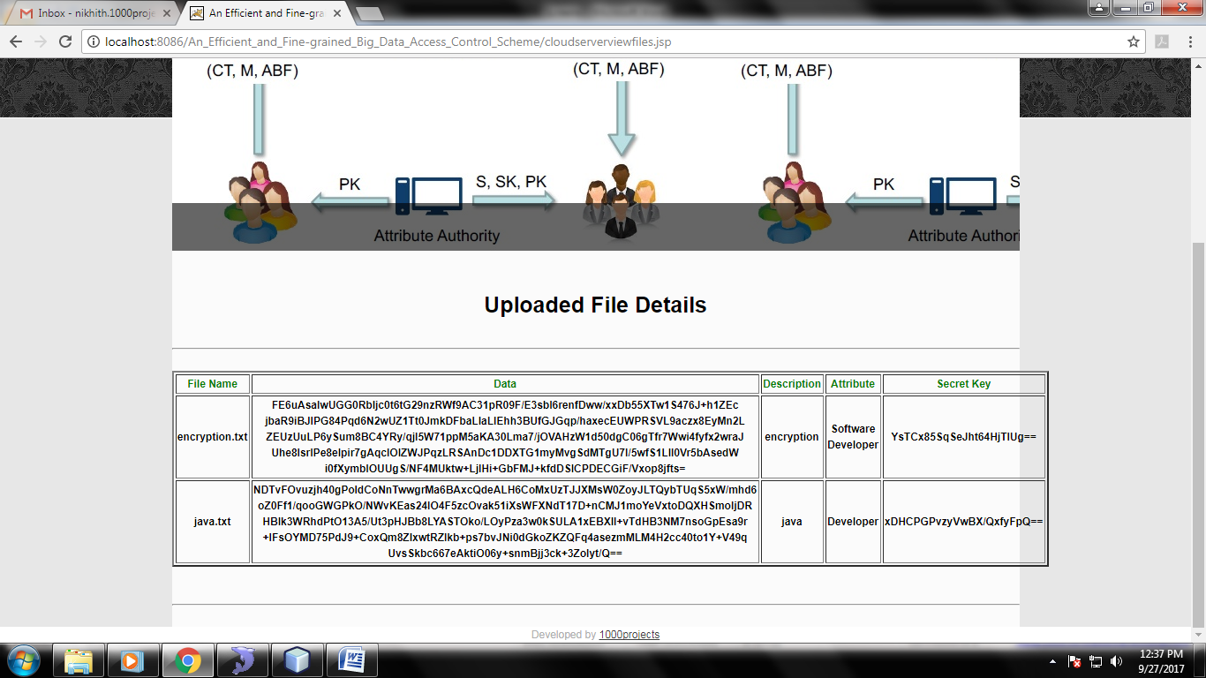

Fig: View cloud Files

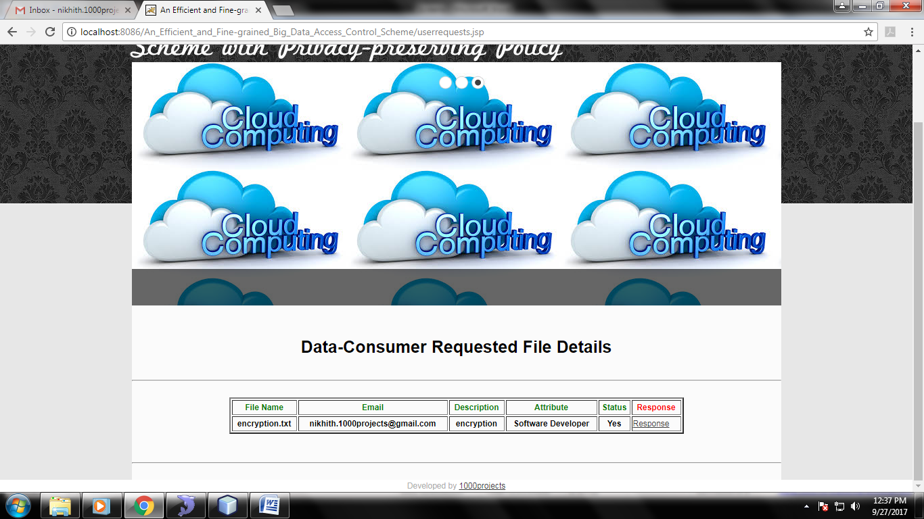

Fig: Data-consumer Requests

**CONCLUSION**

In this paper, we have proposed an efficient and fine-grained data access control scheme for big data, where the access policy will not leak any privacy information. Different from the existing methods which only partially hide the attribute values in the access policies, our method can hide the whole attribute(rather than only its values) in the access policies. However, this may lead to great challenges and difficulties for legal data consumers to decrypt data. To cope with this problem, we have also designed an attribute localization algorithm to evaluate whether an attribute is in the access policy. In order to improve the efficiency, a novel Attribute Bloom Filter has been designed to locate the precise row numbers of attributes in the access matrix. We have also demonstrated that our scheme is selectively secure against chosen plaintext attacks. Moreover, we have implemented the ABF by using MurmurHash and the access control scheme to show that our scheme can preserve the privacy from any LSSS access policy without employing much overhead. In our future work, we will focus on how to deal with the offline attribute guessing attack that check the guessing “attribute strings” by continually querying the ABF.

**REFERENCES**

C. Dong, L. Chen, and Z. Wen, “When private set intersection meets big data: an efficient and scalable protocol,” in Proc. of CCS’13. ACM, 2013, pp. 789–800.

K. Yang, X. Jia, and K. Ren, “Secure and verifiable policy update outsourcing for big data access control in the cloud,” IEEE Trans.

Parallel Distrib. Syst., vol. 26, no. 12, pp. 3461–3470, Dec 2015.

J. Hur, “Attribute-based secure data sharing with hidden policies in smart grid,” IEEE Trans. Parallel Distrib. Syst., vol. 24, no. 11, pp. 2171–2180, 2013.

P. Mell and T. Grance, “The NIST definition of cloud computing,” [Recommendationsof the National Institute of Standards and Technology-Special Publication 800-145], 2011.

[2] R. Lu, H. Zhu, X. Liu, J. K. Liu, and J. Shao, “Toward efficient andprivacy-preserving computing in big data era,” IEEE Network, vol. 28,no. 4, pp. 46–50, 2014.

[3] K. Yang and X. Jia, “Expressive, efficient, and revocable data accesscontrol for multi-authority cloud storage,” IEEE Trans. Parallel Distrib.Syst., vol. 25, no. 7, pp. 1735–1744, July 2014.

[4] H. Li, D. Liu, K. Alharbi, S. Zhang, and X. Lin, “Enabling fine-grainedaccess control with efficient attribute revocation and policy updatingin smart grid,” KSII Transactions on Internet and Information Systems(TIIS), vol. 9, no. 4, pp. 1404–1423, 2015.

[5] K. Yang, Z. Liu, X. Jia, and X. S. Shen, “Time-domain attribute-basedaccess control for cloud-based video content sharing: A cryptographicapproach,” IEEE Trans. on Multimedia (to appear), February 2016.

[6] B. Waters, “Ciphertext-policy attribute-based encryption: An expressive,efficient, and provably secure realization,” in Proc. of PKC’11. Berlin,Heidelberg: Springer-Verlag, 2011, pp. 53–70.

[7] H. Lin, Z. Cao, X. Liang, and J. Shao, “Secure threshold multi authorityattribute based encryption without a central authority,” in Proc. OfINDOCRYPT’08. Springer, 2008, pp. 426–436.

[8] T. Nishide, K. Yoneyama, and K. Ohta, “Attribute-based encryptionwith partially hidden encryptor-specified access structures,” in Appliedcryptography and network security. Springer, 2008, pp. 111–129.

[9] J. Li, K. Ren, B. Zhu, and Z. Wan, “Privacy-aware attribute-basedencryption with user accountability,” in Information Security. Springer,2009, pp. 347–362.

[10] D. Boneh and B. Waters, “Conjunctive, subset, and range queries onencrypted data,” in Theory of cryptography. Springer, 2007, pp. 535–554.

[11] J. Katz, A. Sahai, and B. Waters, “Predicate encryption supportingdisjunctions, polynomial equations, and inner products,” in Advancesin Cryptology–EUROCRYPT’08. Springer, 2008, pp. 146–162.

[12] J. Lai, R. H. Deng, and Y. Li, “Fully secure cipertext-policy hiding cpabe,”in Information Security Practice and Experience. Springer, 2011,pp. 24–39.

[13] L. Lei, Z. Zhong, K. Zheng, J. Chen, and H. Meng, “Challenges onwireless heterogeneous networks for mobile cloud computing,” IEEEWireless Communications, vol. 20, no. 3, pp. 34–44, 2013.

[14] K. Zheng, Z. Yang, K. Zhang, P. Chatzimisios, K. Yang, and W. Xiang,“Big data-driven optimization for mobile networks toward 5g,” IEEENetwork, vol. 30, no. 1, pp. 44–51, 2016.

[15] Z. Su, Q. Xu, and Q. Qi, “Big data in mobile social networks: a qoeorientedframework,” IEEE Network, vol. 30, no. 1, pp. 52–57, 2016.

[16] H. Li, D. Liu, Y. Dai, and T. H. Luan, “Engineering searchableencryption of mobile cloud networks: when qoe meets qop,” IEEE

Wireless Communications, vol. 22, no. 4, pp. 74–80, 2015.